The Plum Stone Game

Subject: Mathematics Creators: Alison Kimbley
and Harley Weston
Strand: Statistics and Probability Grade: 6
Content (topic)

Demonstrating Probability
Outcomes  SP 6.2: Demonstrate understanding of probability by:  - Determining sample space  - Differentiating between experimental and theoretical probability  - Determining the theoretical probability  - Determining the experimental probability  - Comparing experimental and theoretical probabilities | Indicators  SP 6.2b: List the sample space (possible outcomes) for an event (such as the tossing of a coin, rolling of a die with 10 sides, spinning a spinner with five sections, random selection of a classmate for a special activity, or guessing a hidden quantity) and explain the reasoning.  SP 6.2e: Explore and describe examples of the use and importance of probability in traditional and modern games of First Nations and Métis peoples.  SP 6.2f: Predict the likelihood of a specific outcome occurring in a probability experiment by determining the theoretical probability for the outcome and explain the reasoning.  SP 6.2g: Compare the results of a probability experiment to the expected theoretical probabilities.  SP 6.2h: Explain how theoretical and experimental probabilities are related.
Lesson Preparation
Equipment/materials:
- One set of game pieces for each group of students.
- One basket for each group of students or piece of leather approximately 30 cm x 30 cm.
Advanced Preparation:
- Rather than using a basket or a piece of leather to toss the pieces it may be easier to toss them on a table or the floor as you would dice.
- In the example score sheet below Alison took 13 tosses to reach a score of 7. In the process she received a score of zero, 7 times. Hence from this instance of the game, the experimental probability that the game results in a zero score is 7.13 or .54.
Presentation
Development

If your students have played the plum stones game before you can proceed to the Modified Play section.
- This game was taught to us by Lamarr Oksasikewiyin from Laronge Saskatchewan. He told us that the original game pieces were plum seeds but we have used slices of deer antler.
- You might use plastic or wooden disks that you can find in a craft store.
- There are five game pieces, three of which are marked on one side and unmarked on the other side and the other two pieces have a star on one side and a moon on the other.
- All five game pieces are placed in a bowl and the players take turn gently flipping the bowl so that the pieces are all in the air and then land in the bowl. If the pieces are not all in the air during the toss then no score is recorded and the bowl passes to the next player.
Scoring:
- For a non-zero score to be recorded all three marked-unmarked pieces must land the same way up, either all marked or all unmarked.
- If these three pieces show a mixture of marked and unmarked sides then a zero score is recorded and the bowl passes to the next player.
- If the all three marked-unmarked pieces land the same way up then the other two pieces determine.
- If they match, two stars or two moons, then the player receives 2 points. If they are unmatched then the player receives 1 point.
- If a player scores then he or she plays again. Before starting the players should decide how long the game will last, possibly until one player reaches 11 points. (See Appendix A and B)
- An example score sheet is provided is Appendix C
Modified Play:
- The play is divided into two parts, 1 and 2.
- First, toss one of the marked-unmarked pieces and then the second marked-unmarked piece. If they don't match, a score of zero is recorded and the game pieces are passed to the next player who repeats part 1. If they match proceed to part 2.
- Toss the first star-moon piece and then the second star-moon piece. If they match, two stars or two moons, then the player receives 2 points. If they are unmatched then the player receives 1 point. The same player plays again starting at part 1.
- Toss the first star-moon piece and then the second star-moon piece. Record the score is determined by the scoring rules explained above. Then the same player plays again.
- Have each group of students play this version of the game until each player reaches a score of 7.
- Use the score sheet to keep the score, including how many times a player received a score of zero.
- Have each student use his or her score sheet to determine their experimental probability of obtaining a score of zero.
- Discuss with the entire class the sample space for the first part of the game. The sample space has four possible outcomes.

Questions/ Discussions

- Have the students describe each item in the sample space in words.
- Using the fact that
Theoretical probability = (Number of favorable outcomes)/(Total number of outcomes )
calculate the theoretical probability that a play of the game results in a zero score.
- Compare the results to the experimental probabilities calculated above.
- Why is there more than one experimental probability and only one theoretical probability?
Appendix A
Examples of game pieces
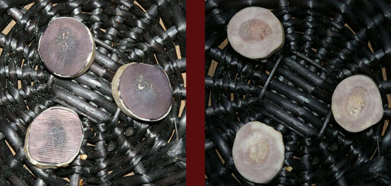

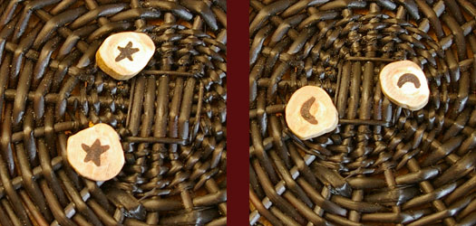

Examples of Points

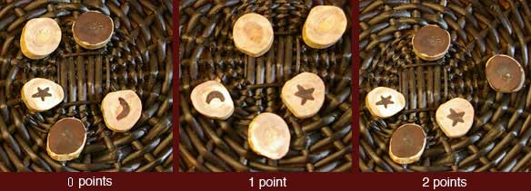

Appendix B
Sample Space has four possible outcomes

First Toss | Second Toss
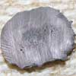 | 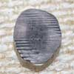
 | 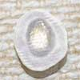
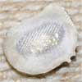

Appendix C
Example Score Sheet

Round | Name | Name | Name | Name
 | Alison
1 | 1
2 | 0
3 | 1
4 | 2
5 | 0
6 | 0
7 | 0
8 | 1
9 | 1
10 | 0
11 | 0
12 | 1
13
14
15
16
17
18
19
20

Appendix D
Score Sheet

Round | Name | Name | Name | Name
1
2
3
4
5
6
7
8
9
10
11
12
13
14
15
16
17
18
19
20

